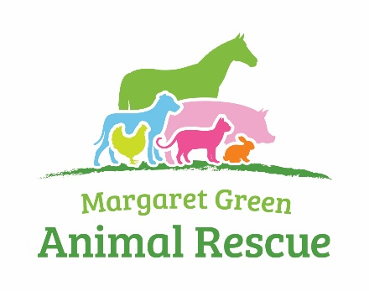

Volunteer Application Form

Volunteer Customer Support Assistant

Personal Details
Title: ………… Forenames: ……………………….………… Surname: ……………………..……………………….
Address: ……………………………………………………………………………………………….……..………………………..………………………………………………………………… Postcode: ………………………………..……
Telephone: Day: .……………………. Evening: ……………………… Mobile: ……………...………..……………
Email Address: ………………………………………………………………..
Please sign me up to the supporter e-newsletter
Do you hold a current driving licence? YES/NO Do you have the use of a car? YES/NO
Are you over 18yrs old? YES/NO
For your information: Some of our roles are physically demanding, please discuss with the Volunteer Co-ordinator prior to completing this form if you have any concerns that you think may affect your work.
I have discussed my concerns with Volunteer Co-ordinator ……………………………………..
I have no concerns
In an emergency, who should we contact?
Name: ……………………………………………………………………………………………………………...………
Address: ……………………………………………………………………………………………………………...………..……………………………………………………………………………………………………………………………………...………..……………
Telephone (include full dialling code) ........................................ Relationship to you: ……….………

Please give details of what interested you in becoming a volunteer at Margaret Green Animal Rescue (please circle all that apply):
A love of animals: YES/NO To work with animals: YES/NO Work Placement YES/NO
To gain work experience: YES/NO To meet people: YES/NO
To keep active and fit: YES/NO You believe in supporting the work of the Charity: YES/NO
You have previously rehomed an animal from the Charity: YES/NO
Other (please specify): …………………………………………………………………………………………………………
Are you, or have you been an animal or pet owner? YES/NO If YES, please give details:
…………………………………………………………………………………………………………………………………………………………
Please give details of any specific experience with rescue dogs, cats and farm animals:
…………………………………………………………………………………………………………………………………………………………
…………………………………………………………………………………………………………………………………………………………
What other kind of volunteer work would you consider taking on at Margaret Green Animal Rescue? (Please tick all that apply):
Collections Animal Welfare Leaflet Distribution
Charity Shops Fundraising Events Catering/Baking
Dog Walking Site Maintenance Gardening
Please indicate how much time you could commit to MGAR on a voluntary basis (please tick the days and times that would suit you best):
Day AM PM Times Available
Monday
Tuesday
Wednesday
Thursday
Friday
Saturday
Sunday

References
Please supply the name and address of a referee and state in what capacity they know you. This should not be close relatives of the applicant.
Name: ………………………………….…………
Address: ………………………………......…………………………………………..….……….…..
Postcode: …………………………………………………….
Mobile No: …………………………………………………….
Home Phone No: ……………………………..………………
Email: ………………………………………..………………….
Rehabilitation of Offenders Act 1974
You must declare any unspent criminal convictions (excluding driving offences) registered against you. If none, please state ‘No convictions to declare’.
………………………………………………………………………………………………………..
General Data Protection Regulation and the Data Protection Act 2018
We will use your information together with other information for administrative and management purposes only. We may keep your information for a reasonable period in accordance with legal requirements if you cease to do voluntary work for us.
By returning this form, you consent to our processing of your sensitive data (such as data relating to your health or criminal convictions) for the above purposes. You have a right to ask for a copy of your information and to correct any inaccuracies.
Your name & signature:
I declare that I have read the Data Protection Notice and all information given in this form is correct to the best of my knowledge.
Print Name: ………………………………..
Signed: ………………………………………………………. Date: …………………………….
Please return your completed Volunteer Application Form to Paula Legg: churchknowle@mgar.org.uk

