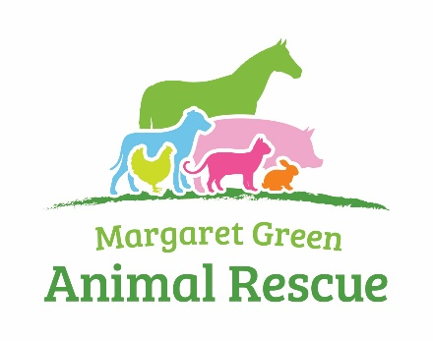

Fundraising Volunteer Application Form

Role for which you are applying: ……………………………………………………………………………….........
Personal Details
Title:………… Forenames: ……………………….…………… Surname: ……………………..……………………
Address:……………………………………………………………………………………………….……..………………………..…………………………………………………………………
Postcode: …………………………………..………………………..
Telephone: Day: ..……………………. Evening: ……………………… Mobile: ……………...………..………
Email Address: ………………………………………………………………..
Please tick that you are happy to receive MGAR updates by:
Email: Phone: Post:
Do you hold a current driving licence? YES/NO Do you have the use of a car? YES/NO
In an emergency, who should we contact?
Name: ………………………………………………………………………………………………………………...………..……
Address:……………………………………………………………………………………………………………...………..………………………………………………………………………………………………………………………………...………
Telephone (include full dialling code) ........................................ Relationship to you: ……….………
How did you hear about volunteering for Margaret Green Animal Rescue?
From a friend From a Volunteer Agency
From a Centre member of staff Website / Social Media
Other (please specify where___________________________)
Please give details of what interested you in becoming a volunteer at Margaret Green Animal Rescue (please circle all that apply):
A love of animals: YES/NO To work with animals: YES/NO
To gain work experience: YES/NO To meet people: YES/NO
To keep active and fit: YES/NO You believe in supporting the work of the Charity: YES/NO
You have previously rehomed an animal from the Sanctuary: YES/NO
Other (please specify): ………………………………………………………………………………………………
Are you, or have you been an animal or pet owner? YES/No If YES, please give details:
………………………………………………………………………………………………………………………………
Please give details of any specific experience with rescue animals:
………………………………………………………………………………………………………………………………………………………………………………………………………………………………………………………………
What other kind of volunteer work would you consider taking on at the Charity (please tick all that apply)?
Collections Leaflet Distribution Baking
Fundraisng Retail Shops
Events Dog Walking
Office Work Cat Companion
If you are able to do so at this stage, please indicate how much time you could commit to the Charity on a voluntary basis (please tick the days and times that would suit you best):
Day AM PM
Monday
Tuesday
Wednesday
Thursday
Friday
Saturday
Sunday

References
Please supply the name and address of a reference and state in what capacity they know you. They should not be a close relative of the applicant.
Name: ………………………………….………… Name: ………………………………………………..
Address: ………………………………......……
……………………………………..….……….……
Postcode: …………………………………..……
Telephone: ……………………………..………
Email: ………………………………………..……
Rehabilitation of Offenders Act 1974
You must declare any unspent criminal convictions (excluding driving offences) registered against you. If none, please state ‘No convictions to declare’.
………………………………………………………………………………………………………..
Data Protection Notice
We will use your information together with other information for administrative and management purposes only. We may keep your information for a reasonable period in accordance with legal requirements if you cease to do voluntary work for us.
By returning this form, you consent to our processing your sensitive data (such as data relating to your health or criminal convictions) for the above purposes. You have a right to ask for a copy of your information and to correct any inaccuracies.
Your name & signature:
I declare that I have read the Data Protection Notice and all information given in this form is correct to the best of my knowledge.
Print Name: ………………………………..
Signed: ………………………………………………………. Date: …………………………….

Please return your completed Volunteer Application Form to: comms@mgar.org.uk

